

# INDUSTRIAL ATTACHMENT PROGRAMME

On

# “ Lac Cultivation – A Profitable Enterprise for Poor Farmers of Jharkhand”

In partial fulfillment of requirements for the award of the degree of**Bachelor of Science (Hons.) Agriculture (2016-2020)**

Of

**Jharkhand Rai University, Ranchi Session 2016-20**

Supervised by :- Submitted by :-

**Prof. Sushma Priya** (Asst. Professor)

Sakshi Anand (BA/16/037)

Sonali Kumari(BA/16/045)

Department of Agriculture

LAC CULTIVATION

### A PROFITABLE ENTERPRISE FOR POOR FARMER OF JHARKHAND

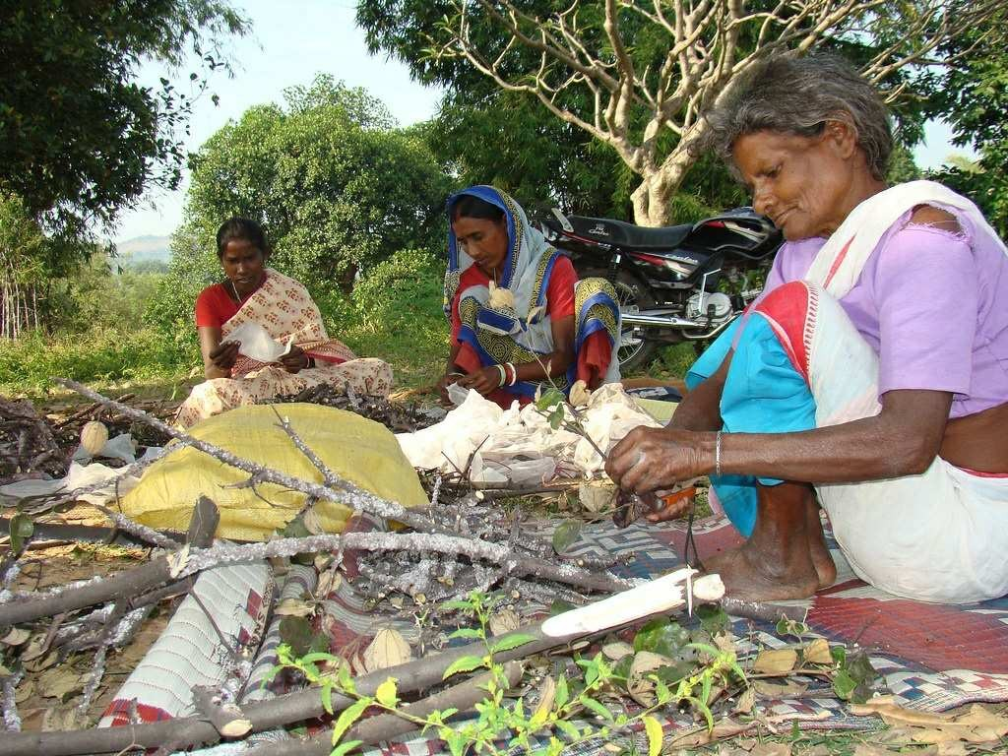

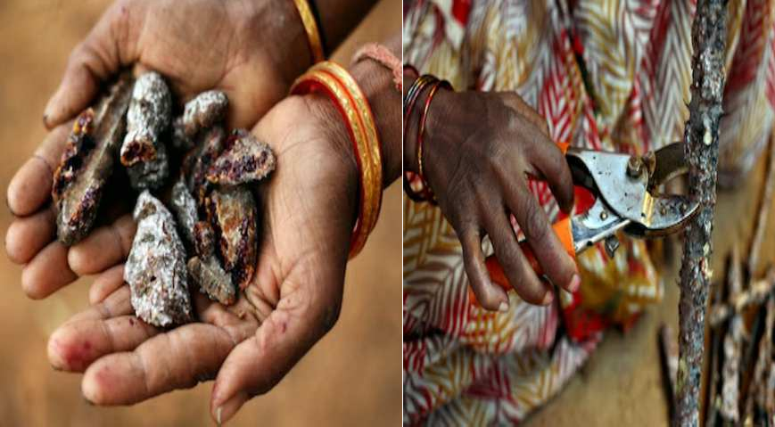

**DECLARATION**

I the undersigned solemnly declare that the report of the project work entitled “**LAC CULTIVATION** – A Profitable Enterprise for Poor Farmers of Jharkhand” is based on my own work carried out during the course of my study under the guidance of**Prof. Sushma Priya** (Asst. Professor) Department of agriculture.

I assert that the statements made and conclusions drawn are an outcome of the project work. I further declare that to the best of my knowledge and belief that the project report does not contain any part of any work which has been submitted for the award of any other degree/diploma/certificate in this University or any other University.

(Signature of the Candidate) Name of the Candidate :-

Sakshi Anand

Sonali Kumari

Sonali Kumari

**CERTIFICATE BY GUIDE**

This to certify that the report of the project submitted is the outcome of the project work entitled “**LAC CULTIVATION** – A Profitable Enterprise for Poor Farmers of Jharkhand” carried out by Carried by under my guidance for the award of degree in **Bachelor of Science (Hons.) Agriculture (2016-2020)** of Jharkhand Rai University, Ranchi, Jharkhand.

Sakshi Anand (BA/16/037)

Sonali kumari(BA/16/045)

sonali kumari(BA/16/045)

To the best of the my knowledge the report:

1. Embodies the work of the candidate him/herself.
2. Has duly been completed.
3. Fulfils the requirement of the ordinance relating to the BSc.(Hons.) Agriculture degree of the University and
4. Is up to the desired standard for the purpose of which is submitted.

(Signature of the Guide) Prof. Sushma Priya Asst. Professor

Department of Agriculture Jharkhand Rai University

## ACKNOWLEDGEMENT

I the students of Jharkhand Rai University have completed my Industrial Attachment RAWE programme, in which I got the opportunity to have firsthand experience of **Agricultural Industrial Attachment Programme (AIAP)**and to gain practical experience in promoting technologies in agriculture among farmers. First and foremost,our utmost gratitude to **Dr. Hemlata Kumari** Coordinator, Department of agriculture, **Jharkhand Rai University**for encouraging me.

I express deep indebtedness to **Dr. Piyush Ranjan**, **(Registrar) Jharkhand Rai University** for providing necessary facilities to complete the work.

I convey my sincere gratitude and thanks to my mentor **Dr. Alok Kumar**(Asst. Professor) Department of agriculture and **Prof. Sushma Priya** (Asst. Professor) under whose guidance I have done my the work.

I would also like to express my gratitude and thanks to myfamily and friends who helped me and supported me in completing my RAWE PROGRAMME by making all the necessary arrangement.

## INTRODUCTION

**AGRICULTURAL INDUSTRIAL ATTACHMENT**

Agriculture education is an important tool in insuring increased agricultural productivity.

Sustainability and environmental and ecological security, profitability, job security and equity.

It is a programme mainly aimed for preparing agricultural graduates for better carrier in agriculture. Providing agricultural graduates oriented education to face the challenges by acquiring knowledge and skill through the hands on experience. Learning by doing is the basic aim and theme of the programme.

Agricultural Industrial Attachment Programme is a programme for importing quality, practical and production oriented for agricultural degree.

The most important achievement of this Agricultural Industrial Attachment Programme is that it builds entrepreneurship development skills and acquaint with new technologies and make us learn about different methods of commercial agriculture and marketing channels.

OBJECTIVES OF AGRICULTURAL INDUSTRIAL ATTACHMENT:-

* To expose the students to industrial environment, which cannot be simulated in the university.
* To familiarized the students with various materials, machines, processes, products and their applications along with relevant aspects of shop management.
* To make the students understand the psychology of the workers and approach to problems along with the practices followed at factory.
* To make the students understand the scope, functions and job responsibilities in various departments of an organizations.
* Exposure to various aspects of entrepreneurship during the programme period.

# CONTENTS

|  |  |  |
| --- | --- | --- |
| **SL.NO.** | **TOPIC** | **PAGE NO.** |
| **1.** | INTRODUCTION | 10-43 |
| **2.** | REVIEW OF LITRATURE | 44-47 |
| **3.** | RESEARCH METHODOLOGY | 48-57 |
| **4.** | CONCLUSION | 58-59 |
| **5.** | BIBLIOGRAPHY | 60-62 |

**FIGURES**

1. State wise Lac production in India 13
2. Crop-wise share in total Lac Production during 2015-16 14
3. Male lac insect 24
4. Female lac insect 25
5. Life cycle of lac insect 26
6. Major host trees of lac 28
7. Harvesting of lac 34
8. Hand made process of lac 36
9. Mechanized heat process of lac 37
10. Different types of lac 38
11. Different lac products 42-43
12. Marketing channel of lac 53

**TABLES**

1. State-wise Lac production in India during 12
2. State-wise Lac production in India during 2013-14 14
3. World EXIM Trade aggregation of Lac, Natural gums, Resins, Gum-resins and Balsams (Value in million US$) 16
4. Habitat characteristics for various host plants used in lac cultivation 29
5. Names of parasites 33
6. Names of predators 34
7. Top lac producing district of the state (Jharkhand) produced over 1000Mt 54

## INTRODUCTION

**LAC CULTIVATION**

Indian subcontinent is the major hub of biodiversity of fauna and flora. Several forest produces have significant importance in social and economic life in tropical areas. These forest produces are classified into wood and non-wood forest produces (NWFP). NWFP includes natural resins, gums and exudates, leaves (tendu), turpentine from pines and perfumery oils from roots, stumps and fruits of various tree species. These are also natural source of spices, medicines, dyes and tannins. Most NWFPs are export currency earners and many are well suited for local small scale industries. There are a large number of lac host and gum producing trees in India which exude resins and gums.There are three categories of natural resins and gums (NRGs) originated from the plants/insects.

Natural resins are solid or semi-solid materials, usually a complex mixture of organic compounds called terpenoides, which are insoluble in water but soluble in certain organic solvents.

Resin is a hydrocarbon secretion of several plants, particularly coniferous trees. Resins are valued for their chemical properties and associated uses such as the production of varnishes, adhesives and food glazing agents. These are also prized as an important source of raw material for organic synthesis and as constituents of incense and perfume. This group of natural resins includes lac secreted by an insect Kerria lacca (Kerr) and plant originated products like rosin, copal and dammer. Solidified resin from which the volatile terpene components have been removed by distillation is known as rosin.

Cultivation of lac is the scientific management of number of species of lac insects to obtain good amount of lac. Lac cultivation involves the selection and maintenance of the host plants, inoculation of host plants with healthy lac insects.

The term “lac” is derived from the Sanskrit word **“Laksha”** meaning a hundred thousand and is suggestive of the large number of insects involved in its production.

Lac insect first scientific account was given by J.Kerr in 1782.

Lac is a natural resin secreted by an insect, known as lac insect**, *Kerria lacca***and ***Laccifer***

##### *lacca.*

Leading producer of lac is **Jharkhand**, followed by **Chhattisgarh**, **WestBengal** and **Maharashtra** states of India.

Lac is mainly produced in India, Thailand, Indonesia, parts of China, Myanmar, Philippines, Vietnam, Cambodia etc. and India is the largest producer of lac in the world.

Rearing of lac insects for commercial production of the lac is called as **lac culture**.

Natural resins are solid or semi-solid materials, usually a complex mixture of organic compounds called terpenoides, which are insoluble in water but soluble in certain organic solvents.

Resin is a hydrocarbon secretion of several plants, particularly coniferous trees. Resins are valued for their chemical properties and associated uses such as the production of varnishes, adhesives and food glazing agents. These are also prized as an important source of raw material for organic synthesis and as constituents of incense and perfume. This group of natural resins includes lac secreted by an insect Kerria lacca (Kerr) and plant originated products like rosin, copal and dammer. Solidified resin from which the volatile terpene components have been removed by distillation is known as rosin.

* + 1. **NATIONAL SENARIO**

Indian subcontinent is the major hub of biodiversity of fauna and flora. Several forest produces have significant importance in social and economic life in tropical areas. These forest produces are classified into wood and non-wood forest produces (NWFP). NWFP includes natural resins, gums and exudates, leaves (tendu), turpentine from pines and perfumery oils from roots, stumps and fruits of various tree species.

Lac cultivation in India at present is very much disorganised the cultivators are still adopting the age old practice which produce a very poor quantity of lac. Over and above the cultivation suffers from shortage of brood lac for infection. Production of lac is, therefore, not regulated to meet the requirement. The host trees are abundant in certain particular belts of the states support the rearing of lac insects. Such trees are Palas, Ber

and Kusum. Due to non-availability of cooking fuel, wood is extensively used resulting in deforestation which is on the increase. As such proper host plant are not sufficiently available for cultivation for the increase of production of lac. Cultivation now a days is more or less confined to the available host plant around the lac cultivators villages.

#### Table 1. State-wise production of Lac in India

|  |  |  |  |  |  |  |  |
| --- | --- | --- | --- | --- | --- | --- | --- |
| **States** | **2010-11** | **2011-12** | **2012-13** | **2013-14** | **2014-15** | **2015-16** | **2016-17** |
| **Andhra Pradesh** | 20 | 120 | 93 | 113 | 170 | 172 | 88 |
| **Assam** | 50 | 100 | 130 | 150 | 285 | 315 | 105 |
| **Chhattisgarh** | 1985 | 3200 | 3260 | 3381 | 2336 | 3187 | 2693 |
| **Gujarat** | 35 | 35 | 55 | 47 | 45 | 48 | 22 |
| **Jharkhand** | 3980 | 10240 | 11020 | 12207 | 8630 | 9950 | 8926 |
| **Madhya Pradesh** | 685 | 1300 | 2524 | 2497 | 2586 | 2222 | 2274 |
| **Maharashtra** | 435 | 950 | 1155 | 1182 | 1525 | 1465 | 875 |
| **Meghalaya** | 5 | 5 | 150 | 168 | 160 | 127 | 20 |
| **Odisha** | 230 | 350 | 310 | 673 | 715 | 623 | 354 |
| **Uttar Pradesh** | 175 | 200 | 100 | 90 | 75 | 55 | 15 |
| **West Bengal** | 1435 | 1400 | 780 | 500 | 451 | 582 | 980 |
| **Total** | **9035** | **17900** | **19577** | **21008** | **16978** | **18746** | **16352** |

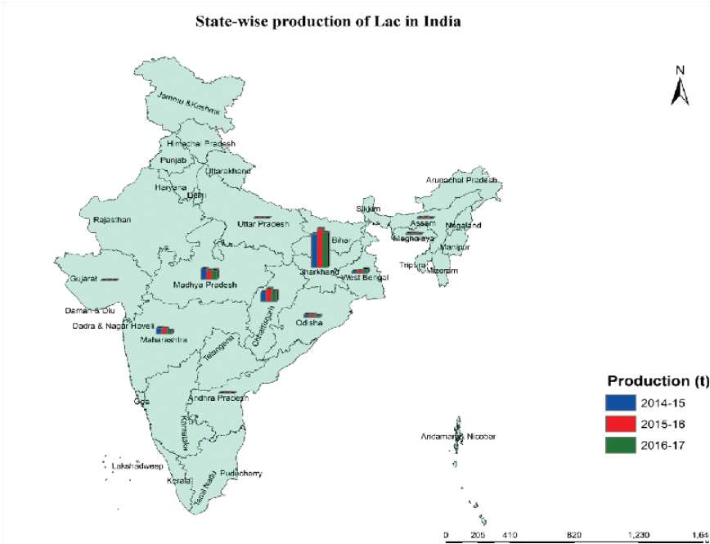

**Fig 1. State-wise production of Lac in India.**

The major lac growing states in the country are Jharkhand, Chhattisgarh, Madhya Pradesh, Maharashtra, Odisha and West Bengal. Uttar Pradesh, Andhra Pradesh,Gujarat and North Eastern Hilly region are other areas where lac is grown. Lac hosttrees are available in plenty in agricultural field, bunds, unused land, degraded landand forest land. Importance of lac has increased for the farmers in the geographicalconditions of major lac producing states. Tribals of mainly depend on agriculture andforest produce for their livelihood and lac is a main source of their cash income. Lac

cultivation also provides employment especially in off-agricultural season. Ranchi,Palamau, Garhwa, Gumla, Simdega, Lohardaga, East and West Singhbhum are the mainlac producing districts in Jharkhand. The national production of lac was 21008 tonsin which contribution of Jharkhand were 12,207 tons during 2013-14. Contributionof *rangeeni* strain was around 40% and *kusmi* strain was around 60% in total lacproduced during 2013-14.

#### Table 2. State-wise lac production in India during 2013-14 (in tons)*

|  |  |  |  |  |  |  |
| --- | --- | --- | --- | --- | --- | --- |
| **Sl. No.** | **Name of the state** | **Name of lac crop** | | | | **Total** |
|  |  | ***Baisakhi*** | ***Jethwi*** | ***Katki*** | ***Aghani*** |  |
| 1. | Jharkhand | 1235 | 6280 | 1080 | 3612 | 12207 |
| 2. | Chhattisgarh | 885 | 855 | 635 | 1006 | 3381 |
| 3. | Madhya Pradesh | 1910 | 48 | 468 | 71 | 2497 |
| 4. | Maharashtra | 625 | 0 | 557 | 0 | 1182 |
| 5. | Odisha | 87 | 251 | 65 | 270 | 673 |

***Baisakhi:-*** Summer season crop of rangeeni; ***Jethwi:-*** Summer season crop of kusmi; ***Katki:***

* Rainy season crop of rangeeni; ***Aghani:-*** Winter season crop of kusmi.

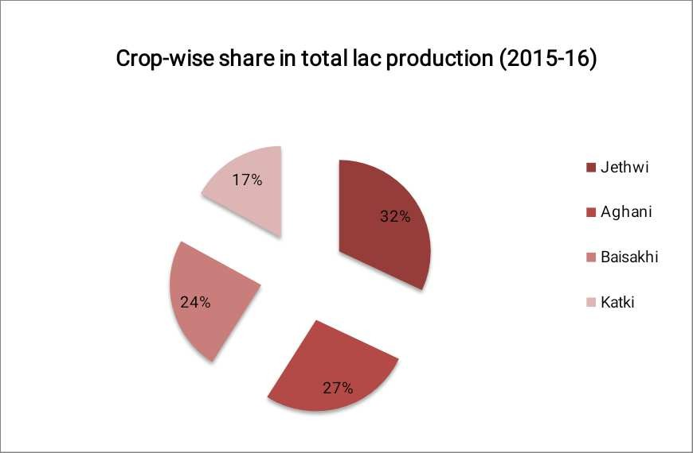

#### Fig 2. Crop-wise share in total Lac Production during 2015-16

Now-a-days, there is increased stress on use of eco-friendly and safe material particularly associated with human contact and consumption. Lac is natural, renewable, biodegradable, versatile and non-toxic resin. Thus, a very good increase in demand for lac world wide is envisaged. The envisaged objective of enhancing lac production has relevance and importance. It is a source of livelihood of tribal and poor inhabiting forest and sub-forest areas.

India is the principal lac producing country of the world, producing approximately 18,000 matric tones of unrefined raw lac annually. About 85% of the country’s production is exported to various countries. The USA, Germany and Egypt are some of the major lac importing countries of the world. Export of lac from India is in the form of shellac/button lac, seed lac, dewaxed lac, bleached lac and aleuritic acid.

India has great potential for lac culture. The areas for lac cultivation can be broadly classified into three categories :-

1. Regular lac cultivation areas – at present, only 20-25% of the total available trees are being utilized.
2. Moderate lac cultivation areas – around 10-15% available trees are being utilized &
3. Lac host tress are available but due to lac of knowledge and awareness, non of the trees are utilized for lac cultivation.

Thus, on an average, only 15% of the available lac host trees owned by farmers are being utilized for lac cultivation presently. There are vast untapped areas, which are ecologically favourable lac production in the country. These areas posses the potential lac host plants which if exploited properly in scientific and systematic manner is liable to enhance the lac production. Enhancing the exploitation of the ideal or unexploited lac host plants in favourable lac growing areas can also enhance the lac production. Indian Lac Research Institute (ICAR), Namkum, Ranchi established in 1924 is actively engaged in addressing the objective of enhancing the lac productivity and production through transfer and adoption of proven technologies by interfacing research, development and extension.

## ECONOMICS AND MARKETING OF NATURAL RESINS AND GUMS

Natural resins and gums NRG production level has been estimated about 837580 tons during 2012-13. The detailed information about state-wise production of guar seed, karaya gum, dhawda gum, babul gum, etc.

#### Table 3. World EXIM Trade aggregation of Lac, Natural gums, Resins, Gum-resins and Balsams (Value in million US$).

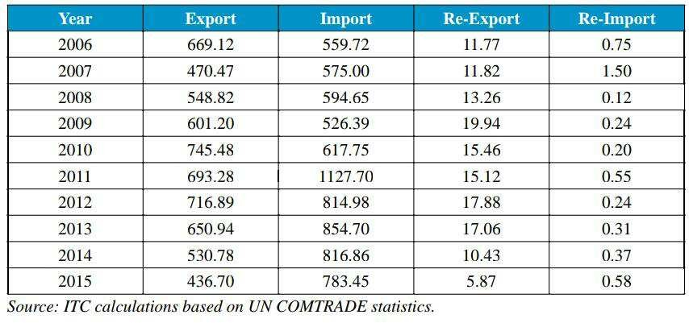

**Guar gum:**

Guar gum/split is extracted from guar seed which accounts for 30 per cent of whole seed (± 4% variance). The ratio of churi and korma varies from 30 to 41 per cent depending upon the quality of seed. Guar gum is further refined to guar powder, while churi and korma are used as cattle feed. Guar seed is drought tolerant kharif crop, mostly cultivated in northwestern parts of the country. This crop is a rain-fed crop that requires 3-4 spells and grown well in sandy soil. The crop is grows from July and extends up to August. It is harvested from September to December. Peak arrival of the crop in the market is seen in October to December while lean arrival in the months of January to May.production of guar gum in 2012-13 was 2447.7 tons and 4924.9 ha. Area was under production.Rajasthan is the leading producer of guar in INDIA.

#### Major destinations :

Guar gum is exported across the globe in 124 countries. About 84 per cent was exported (quantity) to top 10 countries and rest 16 per cent is exported to 114 countries. Other countries are U K, Canada, Phillipnes, Indonesia, Brazil, Vietnam Soc Rep, Egypt, A Republic, Poland, Belgium, Iran, Thailand, France, Japan, Denmark, Mexico, Greece, Korea Republic, Spain, UAE, Pakistan, etc. Agricultural exports increased from ` 86000 crore in 2011-12 to ` 107000 crore in 2012-13 registering a growth of nearly 24 per cent. Increase in value of agricultural exports during 2012-13 was primarily on account of higher exports of guar gum, basmati and non-basmati rice, meat and meat preparations. Share of agricultural exports in the total exports increased from 10.5 per cent in 2010-11 to 12.8 per cent in 2011-12 (Annual Report 2012-13, Department of Agricultural and Cooperation, Ministry of Agriculture, GOI). Guar gum has been the topmost export commodity in agri-export during previous two years.

#### Gums production in Jharkhand :-

Data and information was collected from survey in different districts of Jharkhand related to gums production. Gums produced in the state are karaya (S. urens), dhawada (A. latifolia), babool (A. nilotica), jhingan (L. grantis), palas (B. monosperma), salai gum (B. serrata) and char (B. lanzan spreng). The major gum producing districts and areas are Latehar (Garu, Mahuadar, Herhanj, Balumath, Barwadih, Lesliganj, Chhipadohar and Richughutu), Chatra (Lawalang, Pratappur and Kanti), Garhwa (Ramkanda and Bhandaria), Daltonganj (Panki and Chhatarpur) and West Singhbhum (Chakradharpur). Average annual production of all gums in the state is 300 tonso years.

#### Export and import of natural resins and gums:

Data on export and import of natural resins, gums and gum-resins were collected from Directorate General of Commercial Intelligence and Statistics, Kolkata. Total export of natural resins, gums and gum-resins during the year 2012-13 was 340384.6 tons valued ` 21761.2 crores and total import was 89746.6 tons valued ` 785.3 crores. Trend in export of natural resins and gums from India and import in India during previous five years

Major exported items from India are lac, guar gum, karaya gum, asafoetida and major

imported items are lac, rosins, gum arabic and asafoetida. Majority of farmers/collectors engaged in resins and gums tapping are landless, small and marginal, using traditional practice of resins and gums tapping. In the context of the increasing national and global demand for natural and ecofriendly products, the demand for natural resins and gums are also showing an increasing trend over the time.

#### ORGANIZATIONAL AND INFRASTRUCTURAL ARRAMGEMENT

1. ICAR-Indian Institute of Natural Resins and Gums (ICAR-IINRG).
2. The Trible Cooperative Marketing Development Federation if India Limited (TRIFED).
3. The Shellac and Forest Products Export of Promotion Council (SHEFEXIL), Kolkata.
4. The Jharkhand State Co-operative Lac Marketing and Procurement Federation Ltd. (JASCOLAMPF).
5. The Madhya Pradesh State Minor Forest Produce (Trading & Development) Co- operative Federation, Bhopal.
6. Chhattisgarh State Minor Forest Produce (Trading & Development) Co-operative Federation Ltd. (CGMFPF), Raipur.
7. The Girijan Co-operative Corporation Ltd. (GCC), Visakhapatnam.
8. Koval Foundation, Visakhapatnam, Andhra Pradesh.
9. Sahayog Community Coordination Network (CCN), Visakhapatnam.
10. District Industrial Centre, Purulia, West Bengal.

#### LAC RELATED TERMINOLOGY

* + WAX: Long waxy filaments are a striking features of a healthy encrustation of k. lacca .These filaments protrude out of the anal and brachial pores of the female lac cells.It is the mixture of higher alcohol,esters,acidsand hydrocarbons.
* HONEY DEW:The secretion of honey-dew is known to be waste product excreted into the colorectum from the loops of the intestine(filter chamber)
* LAC RESIN:It is an ester complex of long chain hydroxyl fatty acids and sesquiterpenic acid.
* LAC DYE:Lac dye is present of haemolymph and obtained through washing of lac.It is an anthraquinone derivative.
* COUPE:group or set (khand)
* BAISAKHI(Rangeeni summer crop)

Inoculation of lac during Oct-Nov and wwhich is harvested in the month of June-July.

* KATKI(Rangeeni rainy season)

Inoculation of lac insect during June-July and which is harvested in the month of Oct-Nov.

* AGHANI(KUSUMI WINTER CROP)

Inoculation of lac insect during june-july and which is harvested in the month of Jan-Feb.

* JETHWI(KUSUMI SUMMER CROP)

Inoculation of lac inscect during Jan-Feb and which is harvested in the month of June-July.

* BROODLAC(BEEHAN LAC OR BEEJ LAC)

Broodlac means healthy lac encrustation consisting of gravid females about to produce young ones.

* PHUNKI:Phunki is a used broodlac stcks after complete emergence of lac larvae from female cells.
* ARI LAC:If a lac crops are harvested by cutiing down the lac bearing twigs a little before the crop maturity,that lac is known as arilac.
* STICKLAC:Lac resin obtained from scrapping from sticks is called as stickslac.it is called as scrapped lac.
* SEEDLAC:The granulated form of lac resin obtained after crushing and washing of scrapped lac is called seedlac.It is a semi-processed form of lac resin free from insect body,bark etc
* SHELLAC:It is refined commercial form of lac resin,marketed usually in flakes,besides,the lac resin is also marketed in the form of button lac prepared from seedlac either by manual process or hot filteration.
* BUTTON LAC:After melting process,lac is dropped on a zinc sheet and allowed to spread out into round discs of about 3” diameter and ¼”thickness is called buttonlac.
  + 1. **LAC, LAC INSECT AND LAC CROPS :-**

Lac is a natural resin, secreted by a tiny insect known as lac insect. Lac insect belongs to Coccid group of order *Homoptera*. In India, 19 species of lac insects are found ofwhich three species *i.e. Kerria lacca, K. chinensis* and *K. sharda* are mainly used forlac production. Most important lac insect of commercial importance is *Kerria lacca*(Kerr.). Two strains of *K. lacca i.e. rangeeni* and *kusmi* produce two crops each in ayear (bi-voltine) and contribute significantly in lac production. *Kusmi* insect growswell on *kusum* (*Schleichera oleosa*) and *rangeeni* strain grows well on *palas* (*Buteamonosperma*). *Rangeeni* strain produces two crops in a year known as *katki* (rainyseason) and *baisakhi* (summer season) crop while *kusmi* strain also produces twocrops in a year known as *aghani* (winter season) and *jethwi* (summer season) crop.Lac host plants *i.e. palas (B.monosperma); ber (Ziziphus mauritiana)* and*kusum(S. oleosa)* are commercially utilized for lac cultivation in India. *Palas* is used for*rangeeni* lac cultivation, *kusum* for *kusmi* lac cultivation while *ber* is used for both typeof lac cultivation. Lac insects grow well in moderate weather. Annual rainfall of 1000 to1500 mm with average temperature (24- 270C)may be considered good for lac cultivation.Distribution of rains is very important forsuccessful lac production. Consecutive weeks

with more than 50 mm rainfall during criticalstages of lac development affect the lac yield. Lac growers harvest two crops annually from*rangeeni* strain (October-November and June

-July) and *kusmi* strain (January-February andJune-July) of lac insect. The thrust areas of laccultivation include planting of new host plantsin the traditional and non-traditional area tosolve the problem of broodlac, productivityenhancement of existing plantations throughadoption of scientific lac cultivation practices,quality up gradation of natural lac throughcommunity processing, modernization of lacprocessing factories and effluent treatment,promoting group approach in planting,pruning, processing and marketing through societies and special programmes for

doubling the coverage of available lac host plants, with the involvement of concernedstate governments. A complete package of practices of lac cultivation for one hectareis given in monetary terms.

#### LIFE CYCLE OF LAC INSECT

The Life cycle of lac insect takes about six months and consists of stages:-

1. Egg
2. Nymph
3. Instars
4. Pupa &
5. Adult.

* The lac insects have an ovoviviparous mode of reproduction.
* Female lays 200-500 ready to hatch eggs, i.e. the embryos are already fully developed in eggs when these are laid.

**MALE LAC INSECT:-**

* After the first moult, both male and female nymphs lose their appendages, eye and become degenerate.
* While still inside their cells, the nymphs cast off their second and third moult and mature into adult.
* Both the male and female larvae become sexually mature in about eight weeks.
* Only the male one undergoes a complete metamorphosis or transformation into another form; it loses its proboscis and develops antennae, legs and a single pair of

wings.

* It is contained in a brood cell somewhat slipper like with a round trap door (operculum) through which it emerges.
* The adult male is winged and walks over the females to fertilize them.

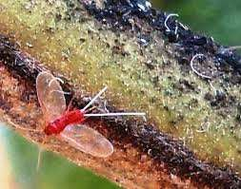

#### Fig 3. Male lac insect.

**FEMALE LAC INSECT:-**

* The female brood cell is larger and globular in shape and remains fixed to the twig.
* The female retains her mouth parts but fails to develop any wings, eyes or appendages.
* While developing, it really becomes an immobile organism with little resemblance to an insect.
* Females become little more than egg producing organisms.

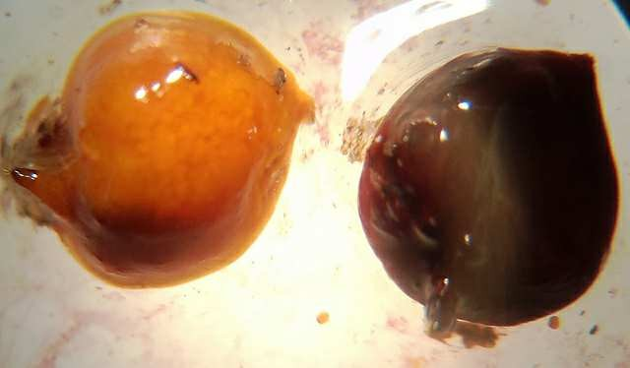

#### Fig 4. Female lac insect

**LIFECYCLE**

* **The emergence of nymph is** called swarming, and it may continue for 5 weeks.
* The nymphs crawl about on branches.
* On reaching soft succulent twigs, the nymphs settle down close together at rate of 200-300 insects per squire inch.
* At this stage, both male and female nymphs live on the sap of the trees.
* They insert their suctorial proboscis into plant tissue and suck the sap.
* After a day or so of settling, the nymphs start secreting resin from the glands distributed under the cuticle throughout the body,except mouth parts, breathing spiracles and anus.
* The resin secreted is semi-solid which hardens on exposure to air into a protective covering.
* The nymphs molt thrice inside the cells before reaching maturity.
* The duration of each instar is dependent on several factors, viz. temperature,humidity and host plant.

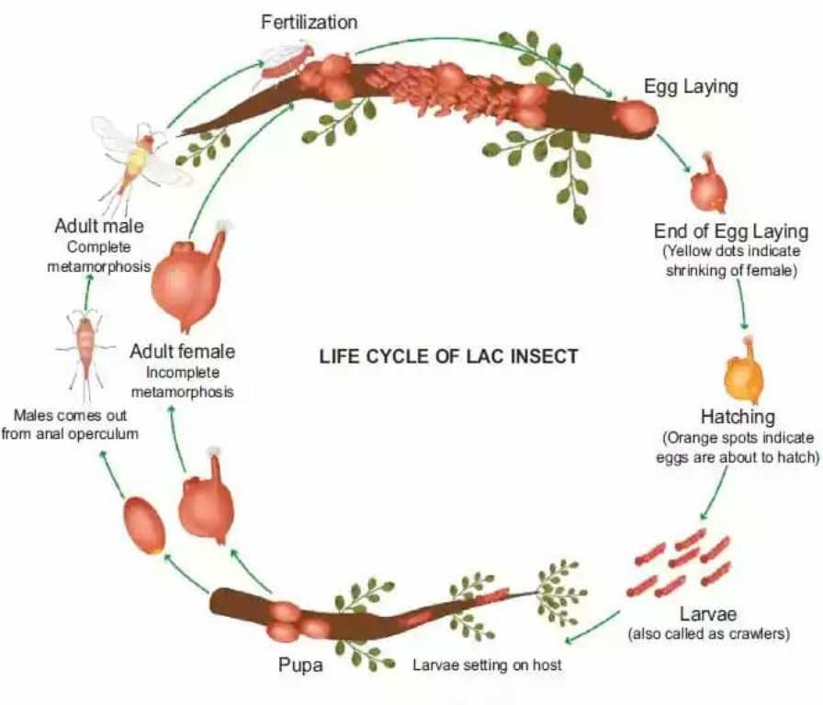

#### Fig 5. Life cycle of lac insect.

* + 1. **MAJOR HOST TREES/PLANTS OF LAC**
       1. **KUSUM (*Scleichera oleasa)***
          - It is the major host tree for kusumi lac cultivation.
          - The best quality resin produced by kusumi strain is obtained from kusum in India only.
          - Family – Sapindaceae
          - The host tress tops the list for its highest production record of 100kg sticklac per tree.
          - The contribution in total production of kusumi lac is about 35-40% only due to limited distribution in the proximity of forest dwellers.
          - There are about 36.7 million trees of kusum in the country.
          - Mainly two crops of kusumi strain (*Jethwi & Aghani*) is harvested annually.

*Jethwi* crop cultivation – Jan-Feb to June-July (6 months).

*Aghani* crop cultivation – June-July to Jan-Feb (6 months).

* + - 1. **PALAS (*Butea monosperma)***
* It is the most wide soread tree in India and major lac host tree for rangeeni lac cultivation.
* Family – Fabaceae/Papilionaceae.
* About 45% of entire lac produced in the country is from rangeeni strain and of which about 65% is contributed by Palas.
* There are about 491.7 million trees of palas in the country.
* Mainly two crops of rangeeni strain (*Baisakhi & Katki)* are harvested in a year.

*Baisakhi* crop cultivation – Oct-Nov to June-July (8 months).

*Katki* crop cultivation – June-July to Oct-Nov (4 months).

##### BER (*Ziziphus mauritiana)*

* It is a major host plant for cultivation of both kusumi and rangeeni strains of lac insect.
* Family – Rhamnaceae
* About 93 million trees of ber available in the country, may be used for lac cultivationfor income generation.

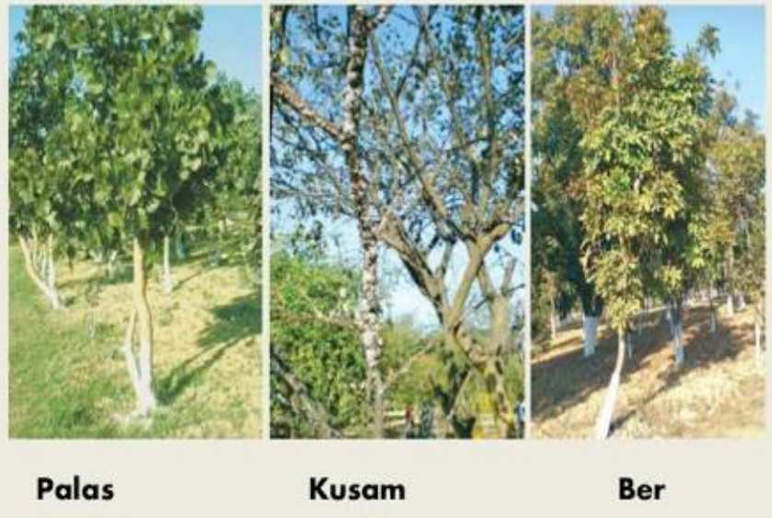

#### Fig 6. Major host trees of lac, palas; kusumi; ber.

##### *Flemingia semialata*

* Family – Leguminaceae
* This is a bushy plant with a scope to increase lac production by developing plantation in scientific method.
* This host plant is mainly used for kusumi lac cultivation.

#### CLIMATIC CONDITIONS AND OTHER REQUIRMENTS OF LAC CULTIVATION Table 4. Habitat characteristics for various host plants used in lac cultivation.

|  |  |  |  |  |  |
| --- | --- | --- | --- | --- | --- |
| **Sl.No.** | **Operations** | ***Kusum*** | ***Ber*** | ***Palas*** | ***F.semialata*** |
| 1. | Climate | Tropical | Tropical | Tropical | Tropical |
| 2. | Temperature | 35-47 | 20-48 | 25-47 | 35-40 |
| 3. | Rainfall | 750-2500mm | 470-1200mm | 500-1300mm | 750-2500mm |
| 4. | Soil requirement | Light well drained loamy soils. | Well drained sandy or alluvial land | Poorly drained saline soils. | Well drained soil rich in organic matter. |
| 5. | Land preparation | Levelling | Levelling | Levelling | Levelling & ploughing |
| 6. | pH | Acidic | Acidic & alkaline | Acidic | Acidic & alkaline |

* + 1. **LAC CULTIVATION PRACTICES**

Lac cultivation is done by putting brood lac on suitably prepared specific host plants. The brood lac contains gravid females which are about to lay eggs to give birth to young larva. After emergence from mother cells, the young larva settle on fresh twigs of host plants, suck the plant sap and grow to form encrustations.

1. LOCAL CULTIVATION PRACTICES

Lac cultivation is simple, does not need any large investment and requires only part-time attention. In India, lac cultivation is carried out casually, and the cultivator is satisfied with what he gets, as it is being regarded as subsidiary crop.

The local practices in lac cultivation has some disadvantages like:-

* 1. The same host plants are continuously exploited without giving rest for recoupment.
  2. Only natural inoculation occurs.
  3. Partial harvest is done leaving few branches untouched for auto inoculation of next crop and no pruning is done.

As a result of the defective local practices, host trees loss the vigour and unable to throw out new succulent shoots, and in course of time, the trees become weak and die. The self inoculation leads to heterogeneous infestation of nymphs, which results in wholesome mortality of brood in seasons of extreme heat, and thereby, the cultivator is forced to abandonlac cultivation.

1. IMPROVED PRACTICES

Sustained production of lac and steady returns can be achieved by adopting improved method of cultivation. The underlying principle in improved method of lac cultivation is to provide much needed rest to the host plants after a harvest has been taken. For this purpose, **coupe system** of lac cultivation is adopted. As the term coupe means a chamber, the host plant trees are divided into coupes i.e groups that consists of certain number of trees. In practice, only few number of trees in a coupe are inoculated. Following harvest, these trees are made to rest and recoupe the lost vigour, while other trees (which have till now been restring) are ready with succulent twings for inoculation thus, in a coupe system, alternate groups of trees are put to lac cultivation. Full incolulation and full cropping is the rule under this system. In-addition, the following considerations are desirable in improved lac cultivation :-

* The mean lac productivity (per tree and per unit area) of 2,5 and 15kg per tree 3, 4 and 5q per hectare for palas, ber and kusum respectively in traditional lac culture is very low. This is all due to poor sustainability, continuous exploitation and increased threat from pests. So, the technology of improved scientific method of lac cultivation should be adopted, that includes superior breeds of lac insects, providing proper rest to host plants, use of wood, quality brood lac is appropriate quantity, post-harvest management of lac crop, host plant management and lac pest management.
* As the lac cultivation is mainly practiced by the forest and forest fringe dwellers, their involvement in the joint forest management (JFM) programs in different lac growing states is likely to enhance the lac production. Lac host trees under the custody of state forest department are out of reach of the forest dwellers and interested lac growers and are not being utilized for lac cultivation. If these are jointly managed by forest department and forest dwellers and they work in close association, it will be a boon for lac cultivation and production.
* Timely availability of pest free and quality brood lac is the most important input for lac cultivation. Quality brood lac ensures high fecundity of insects and fewer requirements of inoculums. Timely harvesting of mature crop and proper inoculation will reduce the risk of loss of lac insect to a large extent.

#### STAGES INVOLVED IN LAC CULTIVATION

There are four main stages involved in lac cultivation:- Stage 1: Inoculation

Stage 2: Swarming Stage 3: Phunki removal

Stage 4 : Harvesting of lac

#### INOCULATION

The first stage of lac cultivation is inoculation. It is the **process** by which newly hatched (brood) nymphs get associated with new branches of host plant.

Inoculation is of two types:-

1. **Natural or self/auto-inoculation** – This type of inoculation occurs naturally. It is very simple common process, when the swarmed nymphs infect the same host plant again, natural inoculation, being repeated on the same host makes in host

plant weak, and thereby, nymphs do not get proper nutrition. Also in natural inoculation, it is not sure that uniform sequence take place. Therefore, natural inoculation should be discouraged.

1. **Artificial inoculation**–It is brought about by the agency of man. The main idea behind artificial inoculation is to check the drawbacks of natural inoculation. In this method, the host plants are first of all pruned in Jan or June. Pruning means cutting away old, weak and diseased twigs. It includes host plant to throw out new succulent twigs and is as important in lac culture as ploughing is for seed sowing in agriculture. Pruning should be done with a sharp instrument (secateurs, pruning shaw and pruning knife) to give a sharp and neat cut. Only light pruning should be carried out. In artificial inoculation, brood twigs are cut in size 20-30cm in length. Then, the cut pieces of brood twigs are tied to fresh tree twigs in such a way that each stick touches the tender branches of tress at several places. The nymphs swarm from brood and migrate to tender and succulent twigs and infest them. Following swarming, the brood twigs should be removed from the host plant, as this would decrease the chance of pest infestation.

Following precautions are desirable is artificial inoculation:-

1. Fully mature and healthy brood free from pest infestation should be taken.
2. Brood meant for inoculation should not be kept for long and used immediately after crop cutting.
3. Tying of the brood lac stick should be done securely on the upper surface of branches. This will prevent falling of twigs and provide full contact for quick and easy crawling of the nymphs. One should keep a watch on the brood lac dropping down.
4. Sometimes due to bad weather swarming of nymphs from brood is prevented. Hence, the room storing brood lac stick is moderately geated to 200C to induce swarming and then sticks are tied.
5. Generally, cultivation of kusumi in rangini area and vice versa should be avoided.

Brood lac from a particular host used year after year is likely to deteriorate in quality. Therefore, alternation of brood and host give production of better quality of brood lac.

#### SWARMING

It is the most crucial stage of lac cultivation. The colour change of the eggs tells the time of swarming. One should note that, at the time of hatching, hte eggs become orange coloured. Following swarming if nymphs, the hollow cavities left in the cell get covered with- wax. So, it is an indication that swarming has taken place.

#### PHUNKI REMOVAL

It is the process of removal of brood lac twigs which are used for inoculation purpose. The used up brood lac after complete emergence of lac nymphs from female cells is defined as phunki removal. Ordinarily, the emergence of lac nymphs from the brood lac ceases after three weeks.

Then, phunki lac is scrapped off from the brood lac to avoid emergence of enemy insects. These phunki bundles are pulled down from the host trees with the support of pole mounted phunki hook or by climbing on trees.

#### HARVESTING OF LAC

Harvesting is defined as the process of collection of lac from the host trees. This process is done by cutting the lac encrusted twigs when it is matured. Harvesting process can be done in two ways:-

1. **Immature harvesting** – Here, the lac is collected before swarming. Lac, which is obtained, is called ‘ARILAC’. The lac insect may be damaged at the time of immature harvesting that would cause population destruction of lac insects and can result in great economic lost to cultivators. But, in case of palas lac (rangini lac), this type of lac was found to give better quality of production. So, only for this lac immature harvesting is encouraged.
2. **Mature harvesting** – In this process lac is collected after swarming. The lac which

is obtained is called ‘Mature lac’. It is very important to know the exact date of emergence and swarming of nymphs for mature lac harvesting. A simple visual method is adopted for this purpose. However, a yellow spot develops on the posterior side of female lac cell towards crop matuarity.

Then, the spots spread forward until it covers half of the cell. Cutting of twigs for harvesting can be done at any time between the stages. But, the yellow spot occupies one-third to one-half of the cell area. Though, at times it is desirable to wait till the emergence of first new nymph.

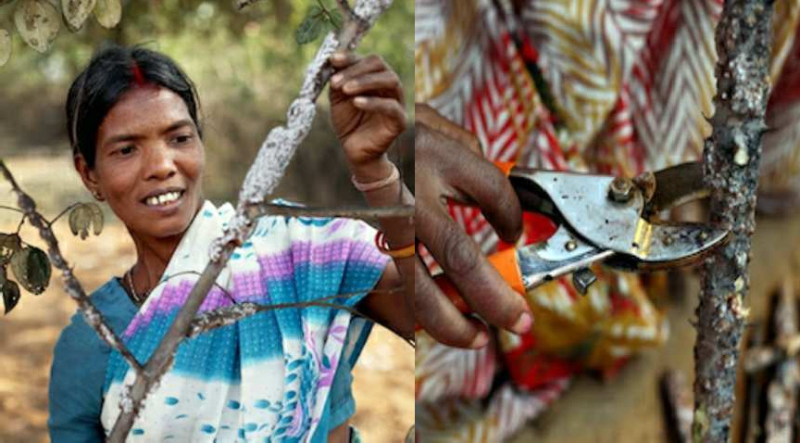

#### Fig 7. Harvesting of lac

* + - 1. **PROCESSING OF LAC**

Processing is done after harvesting of the lac, from the host plants. Processing starts with the scraping of the stick lac from the twig. Now this scrapped lac must be cleaned of the impurities like dead lac insects, eggs and colouring matter. After cleaning the lac is finally crust with the help of hand-operated morters. This crust lac is air dried after which it forms pale yellow colour granules. This is called as seed lac.

Seed lac is then soaked in water, washed, dried in sunlight, bleached and heated to melt in

on charcoal file in cloth bag. During heating the bag is twisted and the lac is squeezed out of the bag with the impurities left out in the bag. This lac is called as Kirri lac.

Kirri lac is allowed to cool down and solidify around button shaped forms to form button lac or pure lac. This pure lac is stretched into thin sheets called as Sheet lac. The sheet lac when dissolved in water produces white or orange coloured lac called as Shell lac.

The quality of the lac depends on the host plant. Kusumi lac is said to be best and costly lac while Dhak lac is said to be the worst lac and the cheapest one. The quality and colour of the lac vary depending on the presence of gum and resins in the host plant.

#### Parasites & (II) Predators :-

(i) Parasites : All parasites causing damage to lac insect belong to the Order Hymenoptera ofclass Insecta. A list of parasites associated with lac insect (*Kerria lacca)* is presented below :

#### Table 5. Names of Parasites

|  |  |  |
| --- | --- | --- |
| **Sl. No.** | **Name of Parasite** | **Family** |
| 1. | *Anicetus dodonia* | Encyrtidae |
| 2. | *Atrophates hautefeuilli* | Encyrtidae |
| 3. | *Aphrastrobracon flavipennis* | Encyrtidae |
| 4. | *Bracon greeni* | Encyrtidae |
| 5. | *Campyloneurus indicus* | Encyrtidae |
| 6. | *Coccophaqus tchirchii* | Aphelinidae |

1. **Predators :**

The predators on the other hand, are more serious and may cause damage up to 30-35 percent tothe cells in a crop.The list of predators of lac insects are given below:-

#### Table 6. Names of Predators

|  |  |  |
| --- | --- | --- |
| **Sl. No.** | **Names of Predator** | **Family** |
| 1. | *Eublemma amabilis* | Noctuidae |
| 2. | *E. coccidiphaga* | Noctuidae |
| 3. | *E. cretacea* | Noctuidae |
| 4. | *E. scitula* | Noctuidae |
| 5. | *Pseudohypatopa pulverea* | Blastobasidae |
| 6. | *Catablemma sumbavensis* | Blastobasidae |
| 7. | *Cryptoblabes ephestialis* | Blastobasidae |

**MANAGEMENT PRACTICES**

Preventive measures

Parasite and predator free brood lac should be used for inoculation Self inoculation of lac crops should be avoided as far as possible

Inoculated brood bundles should be kept on the host tree for a minimum period only. Phunki should be removed from the inoculated trees in 2 – 3 weeks .

#### Mechanical control

Use of 60 mesh synthetic netting (brood bag) to enclose brood lac for inoculation purposescan reduce infestation of enemy insects of lac.

The emerging lac larvae easily crawl out from the minute pores of the net and settle on the twigs of the lac host plants, whereas the emerging adult predator enemies can not move out of the brood bags and get entrapped within the net.

This can check the egg laying by the predator moths on the new crop.

#### Biological control

Egg parasitoids *viz.* ***Trichogramma achaeae, T. exiguum*** and ***T. ostrniae*** are able to suppressthe ***Eublemma amabilis.***

The reduction in the population of *E. amabilis* up to 77-86 per cent in case of rangeeni crop andup to 52-72 per cent in kusum crop at the dose of 20 egg parasitoid per bush .

#### METHODS OF LAC PROCESSING

Seedlac is often the base material which is further processed

The processing results into a finished product which is known as Shellac

#### Hand Made Process

1. **Mechanized Heat Process**
2. **Solvent Processes**
3. **HAND MADE PROCESS** Traditionally method
   * The seed lac is filled into a long sausage shaped cloth bag of about 2 inch diameter and 30 feet long.
   * The cloth bag is filled with approximately **40 Kgs of seed lac(granular resinous material obtained from stick lac)**
   * The long bag made up of **markin cloth** is passed gradually in front of a charcoal- fired hearthhot enough to melt the lac.

#### By twisting the bag, molten lac is squeezed out through cloth.

* + Due to **hot melting and squeezing,** lac resin is **forced out through the pores of the**

**bag;**leaving behind impurities such as insect bodies or twigs.

* + The residue left inside cloth bag is known as **Kiri lac.**

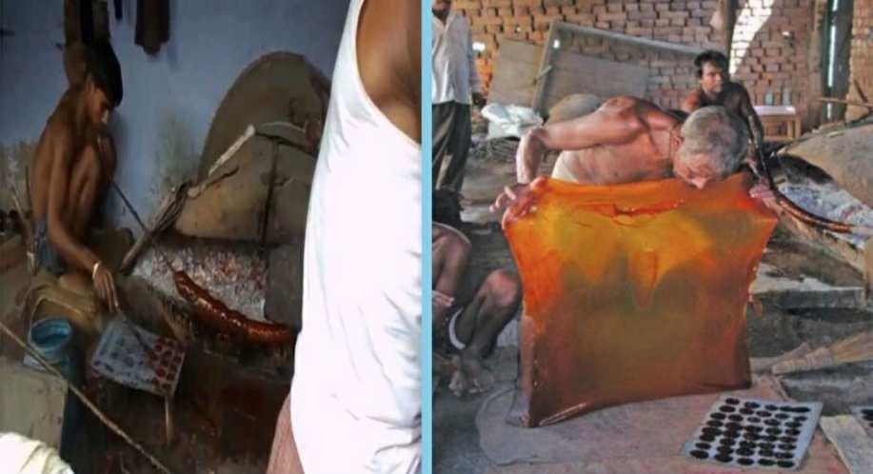

#### Fig 8. Hand made processing of Lac

1. **MECHANIZED HEAT PROCESS**

* In this process of manufacturing of shellac, the seed lac is melted by **steam heat.**
* The molten soft lac is squeezed through **filter by means of hydraulic pressure.**
* The filtered molten lac is drawn into long and continuous sheets with help of roller.
* The sheet is then broken into pieces called **flakes.**

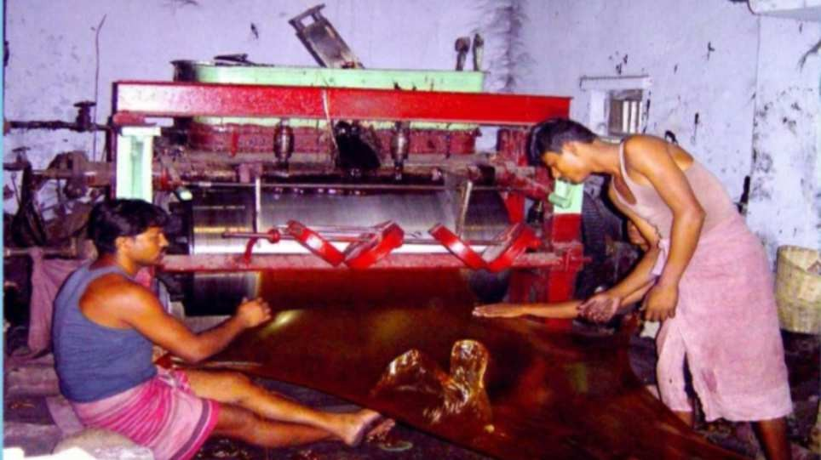

#### Fig 9. Mechanized heat process

SOLVENT PROCESSES

* Solvent process is used to purify the semi refined lac, **dewaxed and decolorized shellac** can beobtained as end product.
* Seed lac is dissolved in a refrigerated alcohol and filter through filter press to remove wax andimpurities.
* The colour may be removed by treating with the activated carbon.
* The molten shellac is stretched with a roller.
* SHELLAC-Lac resin melted into thin flakes.

TYPE OF LAC

**Ari lac –** It is immature lac harvested from the host plants.

**Stick lac –** It is matured lac harvested in the form of stick from host plants.

**Seed lac -** It is obtained after removing and washing the lac from the stick. **Dust lac-** It is obtained after grinding seed lac.

**Shellac –** It is prepared after heating the seed lac and dust lac.

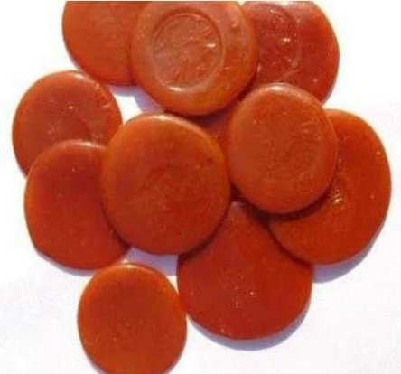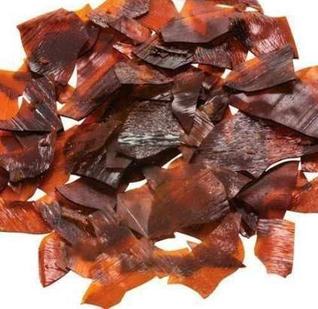

#### Fig. Button Lac Fig. Shellac

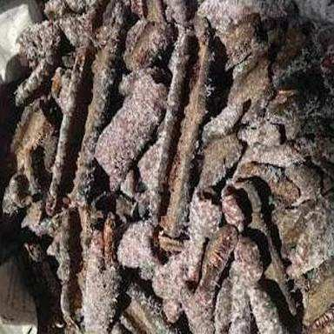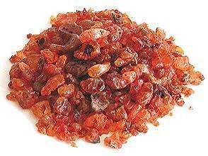

**Fig. Stick Lac Fig. Seed Lac**

**Fig 10. Different types of Lac**

* + - 1. **COMPOSITION OF LAC**

Lac is a complex substance and it also contains sugar, water and other alkaline substances along with the large amounts of resins. The percentages of various constituents ate as follows:-

Resin – 68-90%

Dye – 2-10%

Wax – 6%

Albuminous matter – 5-10% Mineral matter – 3-7% Water – 3%.

* + - 1. **LAC PRODUCTS AND THEIR USES**

Lac has been used for the welfare of human beings from the great olden days no doubt the development of many synthetic products have made its importance to a little leser degree, but still it can be included in the list of necessary articals.

Lac is now being used at industrial level in the manufacturing of various products.Its transformation into various products and their uses are given below

* **Lac dye**

Lac dye is a mixture of Anthraquinoid derivatives. **Use:-**

* It is used in food and beverages industry for coloring.
* It is traditionally used to color wool and silk.
* **Lac wax:**

Lac wax is a mixture of higher alcohols, acids and their esters. It is used as followsfollows:-

**Uses:-**

* Polishes applied on shoes, floor, automobiles etc.
  + Food and confectionary.
  + Drug tablet finishing
  + Lipsticks.
  + Crayon.
* **Shellac**

Shellac is a natural gum resin, it is natural, non-toxic, physiologically harmeless and edible resin.

**Uses:-**

* It is used in fruit coatings, e.g. for citrus fruits and apples, parting and glazing agents for sweets, marzipan, chocolate etc.
* Also used as binder for foodstuff stamp inks, e.g. for cheese and eggs.
* It is used as binder for mascara, nail varnish additive, conditioning shampoo, film forming agent for hair spray, micro-encapsulation for perfumes.
* It is used for enteric (i.e. digestive juice-resistant) coatings for tablets and as odor barrier for dragees.
* Jewelers and Goldsmiths use lac as a filling material in the Hollows in Ornaments.
* It is also used in preparation of Toys, Buttons, Pottery and Artificial Leather

.

* **Bleached Shellac**

Bleached shellac is non-toxic, physiologically harmeless (edible) and is widely used in the food industry, food packaging and allied industries.

**Uses:-**

* Paint Industry (Primer for Plastic Parts and Plastic Film)
* Aluminum Industry (Primer for Aluminum and Aluminum foils)
* Pharmaceutical Companies (for coating of pills, tables, gel caps)
* Confectionery (in coating of confections, chewing gums, marzipan chocolates,

jelly and coffee-beans etc.)

* Textiles (used as textile auxiliaries and felt hat stiffening agents)
* Cosmetics (used in hair spray, hair and lacquers, hair shampoos, and binder for mascara)
* Electric (as Binder for Lamp Cements)
* Plastic (it is Primer for Plastic Parts and Films)
* **Dewaxed Bleached Shellac:**

Dewaxed white shellac is used in the same way as any other grade of shellac. The major differences between this shellac and the others is that it is a bit harder, shines a bit brighter, is completely free from wax. Bleached lac has super characteristics and qualities i.e adhesive, binding, hardening, gloss, odourless. It has good film forming properties, a high gloss and excellent adhesion to various substrate including the human hair. It is non-toxic and physiologically harmless. Good solution can be obtained in ethanol and lower alcohols. It can also be dissolved in water by adding an alkali like Ammonia. It is a compatible with many other resins, raw materials and additives used in cosmetics, pharmaceuticals and food formulations. It is used in,

* Coating of fruits and vegetables.
* Coating in cosmetic industry.
* Coating in tablets and capsules.
* Coating in confectionary.
* Coating in aluminium foil, paper.
* In cosmetics, it is used in hair sprays (pump sprays or aerosolsprays), hair setting lotions, hair shampoos, mascara, eyeliners, nail polishes, lipsticks, microencapsulation by coacervation of fragrances and perfume oils.
* In food, it is used for coating of confections, chewing gum, candles, cakes, eggs, citrus fruits and apples, and printing inks for eggs and cheese.
* **Aleuritic Acid (Shellac Aleuritic Powder)**

Aleuritic Acid obtained from shellac by sponification, is a unique acid containing three hydroxyl groups of which two are of adjacent carbon atoms. Aleuritic Acid is white powder or granule. It is moderately soluable in hot water or lower alcohols (viz. Methyl alcohol, ethyle alcohol and isopropyl alcohol) and crystallizes out on cooling the solution. It is soluable in the lower alcohols such as methyl, ethyl and isopropyl alcohols. Technical grade Aleuritic Acid a slight yellow and almost odourless solid.

**Uses:-**

* Preparation of plastics with good adhesive properties by the condensation of Aleuritic acid with Phthalic Anhydride and Glycerin, rosin etc.
* It is used for manufacturing of perfumes and is very much in demand with perfume manufacturing industries.
* Aleuritic acid esters used in the preparation of lacquers, plastics and fibers.



#### Fig. Lac pens Fig. Cerelac



**Fig. Lac Bangles**

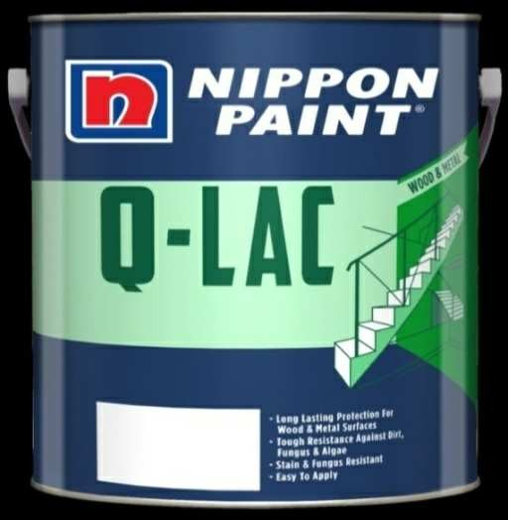

**Fig. Lac handle pocket mirror Fig. Lac paints**

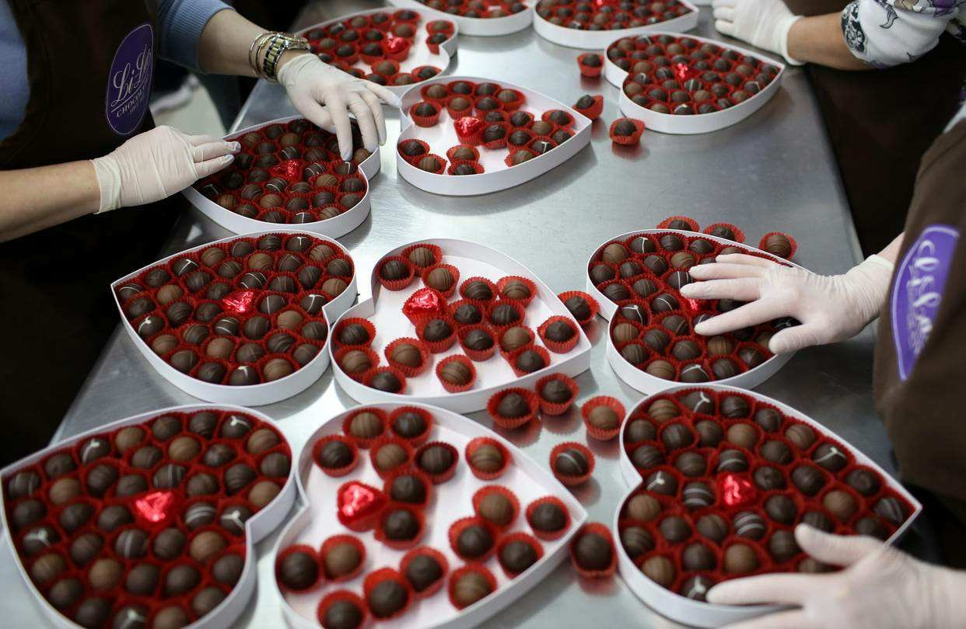

**Fig. Lac chocolates**

**Fig 11. Different products of Lac; lac pen, cerelac, lac bangles, lac mirrors, lac paints, lac chocolates.**

**2. REVIWE OF LITRATURE**

Considering the immense importance of lac in scattered areas of rural India having its unique contribution in foreign exchange earnings and providing means of subsistence, various studies have been made focusing various aspects of lac industry, some of these studies are mentioned here in brief.

1. In his book, “**Handicrafts Survey- A Monograph on Lac Ornaments”,** Census of India 1961, West Bengal & Sikkim, Volume-XVI, Part- VIIA (II) **Sukumar Sinha** (1966) has attempted to highlight the historical aspects of lac industry with special reference to lac ornaments in Jhalda of Puruliadistrict.
2. **S.C Sengupta** (1972) in his article “Twenty Five years of Research in Lac”, published in *Indian Farming* Vol. 22 No. 7 summarises the studies on various aspects of lac industry that is cultivation, processing, production, selling and market operations andutilizations.
3. **K.N. Kabra** (1983) in his book “Dependence and Dominance” focuses attention on historical perspective of lac economy, socio-economic profile of lac growers, lac production, (trends & problems) and lac trade andindustry.
4. A study of socio-economic profile of lac culture is presented by **S.K Saha & S.P Bhardwaj in their article “Lac Cultivation- A Socio-economic Study”** (1985-86), Issue85. Its states that the tribal and other section of society engaged in lac cultivation and related activities because it is a good cash crop. Merchants as well as part- time employed persons are attracted by the lac production, cultivation, collection andmarketing.
5. In the proceedings of the national seminar on ***Lac Industry- Challenges and Solutions***(1997) published by ILRI Ranchi **B. Ekka** in his article “Lac Growers- Experience From Field” highlights the challenges and solutions faced by the lac growers.
6. **R. K. Chaturvedi** discussed, in his article “Role of Co-operative in Lac Marketing”, the same thing from the viewpoint of lac marketing sector. Important studiesalsohavebeendoneheretoidentifytheproblemsrelatedtolacproduction**.**
7. **D.K Bannerjee** in his article “What Does the Future Hold for Lac” argued about the future prospects of lac industry through inventing various uses of shellac.
8. Lac Cultivation in Purulia District” (2001)- A Status report gives us brief insight about lac activities in Purulia on the basis of survey conducted by **“Office of the District Magistrate & Collector” Purulia** in the year2001.
9. The book ***Recent Advances in Lac Culture* edited by K.K Kumar**; **R.Ramani;SharmaK.K**(2002)publishedbyILRI,Ranchidiscussesabouttheimportance oflacculturei) in forest conservation ii) in employment and income generation and

iii) in rural socio-economic upliftment.

10. **A.K. Jaiswal, K.K. Sharma and K.K. Kumar** (2003) in their article “Problem of Lac Growers in Jharkhand State” published in *Journal of Non-Timber Forest Product* Vol. 10 No. 1&2, have attempted to highlight various problems faced by lac growers. They are of the opinion that all the problems become aggravated because of the poverty of lacgrowers.

1. **“The Atlas of Indian Lac”** (1958) provides at a glance useful information and statistical data on lac and its cultivation, and all-important aspects of lac industry and trade, making it possible to view the problem facing the commodity in proper prospective.
2. **Saha S.K.** (1976) in his article “Lac Industry in India” published in *Indian Farming* Vol. 26 No. 6 made an attempt to discuss about shellac industry in different centres, Mirzapur, Jhalda, Balarampur, Tulin, Ranchi, Palamau, Pakur, Madhyapradesh and Umaria.
3. Reports on Problems and Difficulties of Manufactures & Consumers of Lac in India, Published by **I.L.R.I (Ranchi)**, 1985 Different aspects are analysed in this book which is given as follows-
   1. Lac development and its present, past and futureprogrammes
   2. Lac culture and its impact on generation of income andemployment
   3. Lac industry andutilization
   4. Prospects of lac production in the thenBihar
   5. Role of BISCOLAMF and other co-operatives in lacmarketing.
4. **Agarwal S.C; Jaiswal A.K& Krishna Sharma K**(1998) in their article, “Problems and Prospects of Lac Culture in India” in *Journal of Non Timber Forest Products*. Vol.5 No. (1&2) have made an attempt to highlight the various problem and prospects

of lac culture and suggested the ways and means to overcome the problems.

1. **ILRI (Indian Lac Research Institute) Annual Report** 1979& 80, 1987, 1986, 1989-90 concentrated its attention for improvement of lac culture in Purulia District to meet the future challenges. Problems of lac processing and export, marketing problems at growers’ level especially in Purulia district have also been studiedhere.
2. The thesis **“Economics of Lac Industry in India” by Ratna Mukherjee** (2002) has attempted a detailed analysis of important economic variables related with lac industry with the help of empirical data. In the course of study and analysis, certain glaring problems arevisualised.
3. **Mishra YD, Choudhury SG, Bhattacharya A, Bhagat ML, Kumar P** 2000 Advanced Broodlac production Technology on Palas in Hot Areas, *ILRI Bulletin* No. 3, Indian Lac Research Institute (Ranchi) give us conceptual description of broodlac production technology on Palas in Purulia District.
4. ***Industrial Uses of Lac*, Published by Shellac Export Promotion Council, Calcutta** (2000) Lac possesses a rare combination of very desirable properties and thus finds a wide range of applications. These applications are shown in thebook “Industrial Uses of Lac:” It also throws light on the importance and uses of lac from ancient time to modernindustries.
5. **Raj K Yogi**, (ICAR**), Ranganath Ramani, Kewal Krishna Sharma** (IINRG), gave a Model Bankable Projects; Lac Cultvation for livelihood security,ICAR-Indian Institute of Natural Resins and Gums, Ranchi, Jharkhand Sepetember 2006 in which he had given different aspects of Lac cultivation.
6. **Tahir Hussain shah,** Department of Zoology and Biotechnology, Government Model Science College (Autonomous) Jabalpur, M.P, India, 2015, *this is an open access artical distributed under the Creative Commons Attribution License, which permits unrestricted use, distribution and reproduction in any medium, provided the original work is properly cite.*
7. **Moni Thomas,** Consultancy Processing Cell, Directorate of Research Services, Jawahar Lal Nehru Agricultural University, Jabalpur, M.P, India, 2015, , *this is an*

*open access artical distributed under the Creative Commons Attribution License, which permits unrestricted use, distribution and reproduction in any medium, provided the original work is properly cite.*

1. **Rita Bhandari,**Department of Zoology and Biotechnology, Government Model Science College (Autonomous) Jabalpur, M.P, India, 2015, , *this is an open access artical distributed under the Creative Commons Attribution License, which permits unrestricted use, distribution and reproduction in any medium, provided the original work is properly cite.*

23. **R.K Yogi, Alok Kumar, A.K Singh and Nirmal Kumar,** Jharkhand journal of Development and Management Studies, XISS, Ranchi, Vol.15, December 2017, on Marketing Efficiency Of Various Channels For Disposal of Natural Resin in Tribal Area: A Case Study of Central and North Eastern Plateau Zones of India.

## RESEARCH METHODOLOGY

Indian subcontinent is the major hub of biodiversity of fauna and flora. Several forest produces have significant importance in social and economic life in tropical areas. These forest produces are classified into wood and non-wood forest produces (NWFP). NWFP includes natural resins, gums and exudates, leaves (tendu), turpentine from pines and perfumery oils from roots, stumps and fruits of various tree species. These are also natural source of spices, medicines, dyes and tannins. Most NWFPs are export currency earners and many are well suited for local small scale industries. There are a large number of lac host and gum producing trees in India which exude resins and gums.

Lac is an important Non-timber forest produce for livelihoods improvement. It is the most preferable NTEP (Non- timber forest produce) considering its profitability and very low labor requirement in cultivation .It is eminently suited to the farmers living in the vicinity of the forest including women’s as it demands only their part time attention.

Lac is of considerable economic importance in the life of forest fringe communities, especially poor tribal and other marginalised groups. Many cultivators are engaged in lac cultivation out of which many are ST/SC and other economically backward community of the district. Adoption of scientific technology in lac cultivation, lac processing and lac industrial activity would help to enhance income and employment opportunities to these people. It would also help to improve the attitudes of tribal not to destruct forest for their livelihood. In this study, this would like to emphasise the role of lac industry in the socio- economic upliftment of the forest dwellers without displacing them from their habit. Again Lac cultivation is not a large scale plantation or farming. The poor lac cultivators can easily take up lac cultivation for their livelihood. Many jobless tribals collect valuable woods from forest to earn some income. But planting and cultivating lac host preserve the forest from illegal cutting of trees. In lac producing areas, integration of lac with agriculture would help in ecological balance and welfare of tribal.

Important aspects of lac cultivation are:-

* To gain practical knowledge on successful **lac cultivation.**
* To interact with the community people and and get their suggestions and

observations regarding the various processes of **Lac cultivation**.

* To broaden perspective of the farmers and people who are responsible for planning and management of lac cultivation in scientific method.
* To organize Lac grower for developing sustainable enterprise.
* To impart training to Self Help Groups in the cultivation of lac.
* To involve significant women participation.
* To provide job security and income generation to the poor farmers.
* To uplift the farmers life style.
* To promote new innovation made reforming in agriculture.
* To establish own small enterprises.
* For the enterprise management training (EMT) to strengthen their enterprise and coupe up with the market function.
* To consider cost-yield analysis of lac growers.
* To identify the problems of lac growers in the district.
* To analyse price fluctuation of sticklac and to find out its impact on production and marketing of sticklac.
* To find out domestic consumption & trade of lac processed goods.
* To analyse the income and employment generation capacity from cultivation tp processing of lac goods.
* To find out the ways and means for improving the current situation of lac industry in the states and districts and to throw light on the prospect of lac industry.
* To review the measures adopted by government agencies for helping the lac industry and to suggest policy measures, that should be taken by the government

agencies for the growth of lac industry. Implications and Benefits of lac cultivation:-

* **Employment generation**:- Lac cultivation serves as complementary and supplementary sources of income for improving existing livelihood of the farmers in the state of jharkhnad,Chattisghar,Madhya Pradesh, Maharashtra ,West bangal,odisha and other lac producing sates of India.
* **Income generation**:-It is also an assured source of income during lean period of agriculture activities and providing additional source of income and cash flow to the marginal and large farmers.
* **Livelihood improvement**:-Lac cultivation has been an important source of income for livihood of small and marginal farmers and forest dwellers, its cultivation provides an important additional income next only to agriculture.
* **Wide application of added products**:- Lac basically yields three useful materials- resin, dye and wax. These are natural, renewable, non-toxic and eco-friendly and can be put a unbelievably wide range of applications like printing ink, cosmetic industry, rubber industry,electrical industry, paint industry etc.
* **Building Infrastructure Facilities**:- NABARD’s involvement in the lac cluster development programme at Balrampur has also been thought for setting up of common facility cantre for storage of raw material as well as finished products, testing facilities, information access, e-marketing and capacity building. It is also active in setting up of value added products manufacturing unit with public private partnership.
* Enhance productivity, competitiveness and rural growth.
* Equipping tribal women with the skills and tools to cultivate and harvest lac.
* Strengthening the value chain through end-to-end solutions
* Collectivizing producers into Women’s Enterprise Groups and training a cadre of baseness development service providers to provide technical support.
* Setting up Village Level Service Centers for aggregation ,value addition and fair pricing.
* Setting up Lac co-operatives to act as the market facing entity for lac selling.
* Enhance productivity, competitiveness and rural growth.
* Promotes new innovation mad reforming in agricultural.
* Engage themselves in lac production.
* Establish Small enterprises.
* Build their own corpus.
* Connect the producer to the right market so that they can get fair prices.
* Link produces to relevant government scheme such as credit and brood supply scheme for farmers.
  + Udyogini as an resource agency provides them entrepreneurial trainings in the form of Grassroots management training (GMT).
  + Enterprise management training (EMT) to strengthen their enterprise and cope up with the market function

Drawbacks of lac cultivation:-

* Seasonal production of rew material:- The raw lac appears in the market genrally in tow seasons (May-June & Oct-Nov). Consequently, the local factories depend for about six months in a year on lac brought from adjacent areas. In the slack season small factories are forced to close for six months. They re-opens when local lac is available.
* Self life of sticklac and finished products:-The sticklac can be stored upto three years. But the quality of lac resin (melting power, adhesive power, colour etc) is going to deteriorate after few months. The tendency to form lumps, forming hard

blocks of lac is being noticed due to improper storage of sticklac, which is very difficult to work for subsequent processing.

* Inadequate storage facilities:-The inadequate storage infrastructure creats problem in the storage of lac products and the essential properties of these products are deteriorated due to loss of fusibility and solubility.
* Low productivity:- Traditional cultivation practices have not been sustainable due to high pest infestation and over exploitation of host plants. The cultivators do not adopt any new scientific method which can enhance the intensity of lac cultivation. In this method production of lac is small quantity and there is absence of constant impetus for lac growers to produce more.
* Lack of quality awareness of broodlac:- The old method does not give sustained of broodlac which is required twice in a year and thus resulting non-availability or low availability of broodlac of proper quality. Quality of sticklac is also hampered.
* Quality inconsistency:- One of the major threats of the processes of the indigenous factories is the non-uniformity of qualities of the products. Moreover, there is a tendency of admixture seedlac with rosin in the preparation of button lac and shellac and made the product as low graded quality. The good-will of Indian traders has been decreasing.
* There is lack of adequate market information collection and dissemination system. The processor are also negligent in creating a healthy marketing system (bith forward and backward). Unhealthy competitive trade practices are ruling here due to non-existence of professional management and control in the marketing system.

## LAC MARKETING

#### MAKETING DISPOSAL PATTERN OF LAC

Lac Grower

Paikar (Trader)

LAMPS/PACS/VMSS (MSP)

Wholesaler

Lac Arhatia Lac Processor

### Import Export/ Re-export Domestic Consumption

#### Fig 12. Marketing channel of lac

Lac grower have opportunities to sell stick lac in more price through LAMPS in comparison to the local market/ regional market, butthey hardly comes to sell because of delay in payment. The producer farmer was found advantageous in terms of price of stick lac and alternative ways of disposing the stick lac, who are living in nearby areas equipped with lac processing units, when compared to other producer farmer, residing in remote areas. As farmers are mostly marginal, small farmers, have low income, and due ti instance need of money for buying household items, payment of loan, payment for farm inputs etc. Thereby, most of the farmers prefers to sell stick lac in rural market or regional market instead to processor/LAMPS directly.

#### Table 7. Top Lac producing districts of the state (Jharkhand ) produced over 1,000 Mt of lac.

|  |  |  |  |  |  |  |  |
| --- | --- | --- | --- | --- | --- | --- | --- |
| **Sl. No.** | **District** | **2012-13** | **Rank** | **2013-14** | **Rank** | **2014-2015** | **Rank** |
| 1 | Ranchi | 4250 | 1 | 3475 | 1 | 2530 | 1 |
| 2. | Simdega | 2720 | 2 | 2445 | 2 | 1910 | 2 |
| 3. | Gumla | 2270 | 3 | 2380 | 3 | 1330 | 4 |
| 4. | Khunti | - | - | 1790 | 4 | 1380 | 3 |

* + - The cultivation of lac is generally carried out by small cultivators coming from the backward classes, the hill tribes and aboriginals. As the cultivators are ignorant of modern market practices, marketing of sticklac in normal courses is carried out in a traditional way.
    - Since sticklac cannot be stored for long, readily blocking into hard lumps, it has to be processed into Seedlac or shellac as quickly as possible.
    - Facilities to carry out such processing do not exist in the producing village. In view of these inherent drawbacks the lac cultivators, who need cash for purchase of their daily household requirements, dispose the sticklac soon after its collection. For this the producers depend upon the nearest available rural markets known as haats, which are the primary markets for sticklac.
    - In the marketing of sticklac, one comes across a chain of functions and functionaries at various stages.
    - The most important functions involved are assembling, storage, transport. The different functionaries are the producers, village merchants (rakhiwals), the paikars (big & small), the wholesale merchants, lac arhatiyas, representative of factories operating in the village and lac manufacturer. The quantity of lac held by any individual cultivator is very small. This sticklac is dried thoroughly and then stored in

a room.

* + - The storage is usually only for about two to three days until the collection reaches 8- 10 kg.
    - Then the bulk of sticklac in general is carried by lac grower in head loads to haats, which operate once or twice in a week. Otherwise the cultivators visit more than one village to sell their produce.
    - Occasionally, the distance to be covered is more than five miles. In such cases the cultivators travel by bus or cart and at times get a lift in passing trucks. Here in the primary market purchases are made in cash or by payment in kind or in some other way mutually agreed upon.
    - Large producers some times auction the right of lac collection from their trees directly to the paikars. The paikars predominate in the rural haats in the interior. Arhatiyas made payment to wholesalers in cash and deduct 1 percent in cash amount.
    - Arhatiyas supply the raw material (stick lac) to processing units on cash payment at delivery or as loan with an interest rate of 6 to 18 percent per annum. The given data shows the percentage distribution of grower households according to the agency to whom sales are made.

#### QUALITY, PRICE AND RISK FACTORS :

Quality and prices of *kusmi* lac is high in comparison to *rangeeni* lac but productionof *kusmi* lac is less due to various reasons*i.e.* uncertainty in production due to climatechange, shortage of broodlac, height of hosttrees, *etc*. A complete package of practices of laccultivation for one hectare is given in monetaryterms including the risk factors also. Riskaversion techniques are given below:-

* Training programme as well as mobile advisory service on lac cultivation
* Special module for pest management
* Lac production may be taken up on tree hosts as an alternative crop under scanty rain conditions.
* Cultivate lac on tree hosts instead of bushy hosts like semialata under rainfed conditions.
* Nylon net sleeves may be used for broodlac inoculation, only if rains are not expected during next 10 days.
* Those farmers who have already inoculated lac on bushy hosts, mulching should be done for moisture conservation.
* Small water storage structure may be created for life saving irrigation.

#### Financial Aspects:

After discussion about the whole scenario of lac cultivation, financial institutionswill be interested to know the financial viability of this activity. The network of thefinancial institutions in potential lac growing area may target the needy people tofinance through SHG approach. There is good opportunity of these institutions toinvest in the priority sector and generating employment for rural youths. Generallyindividual farmer has the lesser number of lac host trees. Hence, to start lac cultivationas commercial farming activity, the SHG approach will be more reliable, viable and

profitable.Therefore, keeping in view of all the inputs required from land preparation tomarketing of the output, the cost components has been classified in fixed and variablecost complements.

**Prevailing rates and prices:-**The prevailing rates of all the inputs and outputs havebeen considered for the estimation of cost and returns. However, the rates per unitmay differ over the time.

**Margin money :-** The marginmoney / down paymentprescribed are 5%, 10 % and 15% for small, medium andother farmers, respectively.The rest of the cost ofdevelopment will be providedas bank loan.

**Bank loan :-** Bank loan of85-95 % of the total cost ofdevelopment shall be available from the financing institution.Bank loan considered in themodel may vary from 85 to 95.

**Rate of interest:-**The rate of interest to be charged to the ultimate borrower would be guided by RBI guidelines issued from time to time.

**Security:-**Banks are guided by RBI guidelines issued from time to time in this regard.

**Cash flow pattern :-** Since lac is a short gestation crop reaching to the harvestingstage in the 6-8 months, the initial investment is fairly high, but incremental income may be accrued during the same year (in case of *ber*, *palas* and *kusum*) and incrementalincome starts accruing from the second year onwards in case of *Flemingia semialata*.

**Repayment schedule :-** The loan amount disbursed may be recovered during thenext year.

## CONCLUSION

Lac is one the most promising NTFPs that has potential to improve the incomes of all households, irrespective of caste and classes, having access and interest to make use of host trees for generation of additional incomes. Lac activity can become the primary source of livelihood for people of Jharkhand, particularly in Gumla district, over the precarious rainfed agriculture by adopting scientific methods. The model proves that purposive design of institutional mechanisms and interventions suitable for any NTFP is imperative for promoting their respective value chains to address poverty of dependent communities while conserving its resource base.

Udyogini in partnership with PACS Programme has revived the forgotten and insignificant Lac based livelihoods in the trouble torn Gumla district and demonstrated that scientific Lac promotion could be a major intervention for addressing the chronic poverty of rural households in Jharkhand while conserving the biodiversity on private lands in the fringe and inside the forest areas as the producers becoming protectors of trees for their NTFPs. However, the institutions envisaged by Udyogini in Lac vale chain are though in conformity with the gaps and needs of the existing Lac value chains, but they need to be critically reviewed and further capacitated for improving their functional efficiency, role clarity and make them accountable, non competitive and mutually supporting in the overall Lac value chain. The time and effort to prepare these institutional entities, particularly the Cooperatives, for developing professional management, democratic governance andabilities to access and handle financial and government institutional linkages is to be done to achieve their the real impact in the Lac value chain. However, the progress has been noteworthy compared to the time and resources spent till now.

The project can offer many lessons to policy makers and government machinery of Lac growing states to consider Lac cultivation as one of the main poverty alleviation means in the areas where host trees are found abundantly. Scientific Lac activity can be dovetailed inthe government schemes like National Rural Livelihoods Mission (NRLM), Krishi Vigyana Kendra (KVK), Agricultural Technology Management Agency (ATMA) and other rural development schemes in their capacity building programmes and explore for resource allocation to arrange good quality brood supply through establishing brood farms as this model demonstrated, provide credit facilities to Lac growers for inputs purchase and

create enabling institutional support for fair market practices. Udyogini should proactivelyapproach and share the successful experiences and lessons of the model with the government and financial agencies to sensitize them of the potential and formulate projects to scale up the proven practices of the model. The lac growers, processors, traders, exporters and policy makers can plan their operations in time by using timely and accurate estimations. The cultivation of lac on a large number of hosts of different kinds, its collection by numerous small growers, variations in the yield depending on the type and size of the host, cultivation practices and climatic conditions are the major factors influencing the estimation of lac production. Accuracy in production estimate would be helpful in precision planning by all concerned. Besides knowing the present status, it would be helpful in regulating imports, planning for enhanced exports, reasonable prices and reliability in supply of lac based products.nsect which are classified based on preference of the insect for specific host plants.

## BIBLIOGRAPHY

**Raj K Yogi**, (ICAR**), Ranganath Ramani, Kewal Krishna Sharma** (IINRG), gave a Model Bankable Projects; Lac Cultvation for livelihood security,ICAR-Indian Institute of Natural Resins and Gums, Ranchi, Jharkhand Sepetember 2006.

**Ramesh singh,** Department of Zoology, Udai Pratap Autonomous College, Varanasi, 2006.

**Tahir Hussain shah,** Department of Zoology and Biotechnology, Government Model Science College (Autonomous) Jabalpur, M.P, India, 2015.

**Moni Thomas,** Consultancy Processing Cell, Directorate of Research Services, Jawahar Lal Nehru Agricultural University, Jabalpur, M.P, India, 2015.

**Rita Bhandari,**Department of Zoology and Biotechnology, Government Model Science College (Autonomous) Jabalpur, M.P, India, 2015.

**Rameshwar Das, Arvind Kumar,** Lac cultivation and rural livelihood, Institute of Forest productivity, Ranchi, Jharkhand.

**A.K. Jaiswal, K.K. Sharma** and **K.K. Kumar** (2003) in their article “Problem of Lac Growers in Jharkhand State” published in *Journal of Non-Timber Forest Product* Vol. 10 No. 1&2.

**Saha S.K.** (1976) in his article “Lac Industry in India” published in *Indian Farming* Vol. 26 No. 6 , Mirzapur, Jhalda, Balarampur, Tulin, Ranchi, Palamau, Pakur, Madhyapradesh and Umaria.

**S.C Sengupta** (1972) in his article “Twenty Five years of Research in Lac”, published in

*Indian Farming* Vol. 22 No. 7.

**K.N. Kabra** (1983) in his book “Dependence and Dominance” focuses attention on historical perspective of lac economy.

**S.K Saha & S.P Bhardwaj** in their article “Lac Cultivation- A Socio-economic Study” (1985

-86), Issue85.

The thesisby **Ratna Mukherjee** “Economics of Lac Industry in India” (2002). In the course of study and analysis, certain glaring problems arevisualised.

#### Mishra YD, Choudhury SG, Bhattacharya A, Bhagat ML, Kumar P 2000 Advanced

Broodlac production Technology on Palas in Hot Areas, *ILRI Bulletin* No. 3, Indian Lac Research Institute (Ranchi) Purulia District.

**K.K Kumar; R.Ramani;Sharma K.K**edited the book *Recent Advances in Lac Culture*

(2002)publishedbyILRI,Ranchi.

**B. Ekka** in his article “Lac Growers- Experience From Field” highlights the challenges and solutions faced by the lac growers.

**R. K. Chaturvedi** discussed, in his article “Role of Co-operative in Lac Marketing”, the same thing from the viewpoint of lac marketing sector.

**D.K Bannerjee** in his article “What Does the Future Hold for Lac” argued about the future prospects of lac industry through inventing various uses of shellac.

**R.K Yogi, Alok Kumar, A.K Singh and Nirmal Kumar,** Jharkhand journal of Development and Management Studies, XISS, Ranchi, Vol.15, December 2017, on Marketing Efficiency Of Various Channels For Disposal of Natural Resin in Tribal Area: A Case Study of Central and North Eastern Plateau Zones of India.

**Acharya, S.S., & Agrawal, N.L**.(2004). Agricultural marketing in India (IV edition). New Delhi: Oxford and IBH Publishing Co.

**Alex, A., & Vidyasagaran, K.** (2016). The marketing of non-timber forest products in the western ghats region of Attappady, Kerala. Economic Affairs, 61(3): 355-363. Retrived from [http://ndpublisher.in/admin/issues/E AV61N3a.pdf](http://ndpublisher.in/admin/issues/EAV61N3a.pdf)

**Alexander, C.,& Wyeth, J.** (1994). Contegration and marketing integration: An application to the Indonesian rice market. Journal of Development Studies

**Ramasamy, C.** (2016) Agricultural marketing in India: Select issues and recent developments. Indian Journal of Agricultural marketing, 30(3), 5-25. Rao, G.N (1987). Significance of minor forest produce in tribal economy: A case study. Kurukshetra, 7, 23- 28.

**Ravallion, M.** (1986). Testing market integration. American Journal of Agricultural Economics, 68 (1), 102-109.

**Sarker, D.,& Das**, N. (2007). Efficiency of market behaviour of non-timber forest products for households under joint forest management programme (JFMP): A case study in

West Bengal. Indian Journal of Agricultural Economics, 62 (1), 80-97.

**Sidhu, R.S., Sidhu, M.,& Singh, J.M.** (2011). Marketing efficiency of green peas under different supply channals in Punjab. Agricultural Economics Resource Review, 24, 267- 273.

Udyogini, Mahila Kisan Sashaktikaran Praiyojna, Training Module on Package of Scientific Cultivation of Lac, Ranchi, Jharkhand.

**Ali, S.** (2006). “Dimensions of Urban Poverty”, Rawat Publication, New Delhi.

**Bharat, R.** 2010. “Jharkhand; current status of Lac production issue Remedial Measures and Support System for Development”, In Monobrullah Md, Singh, J P, Kumar A, Ramani R (2010). ‘Current issues related to Lac production’, Compilation of talks, 20-21 September, 2010, 56pp.

Websites : https://shodhganga.inflibnet.ac.in [http://en.m.wikipedia.org](http://en.m.wikipedia.org/) https://krishijagran.com https://[www.studyandscore.com](http://www.studyandscore.com/) https://[www.researchgate.net](http://www.researchgate.net/)